2023 Annual Basics School

October 2nd – 6th
Pierre, SD

Hotel Accommodations

A block of rooms has been reserved at the Country Inn & Suites by Radisson. To reserve a room(s), you may phone the hotel at:

1-605-609-0660 no later than August 1st, 2023

Room rates will be $75. If you pay with a county check and have the county’s tax ID number, you will not have to pay the tax, be sure to let them know at time of booking that you are with a tax-exempt entity. If you are paying with a private credit card or check, taxes may apply. When making room reservations, let the hotel know that you are with the “Department of Revenue School” to insure you get the group rate. Please ask for confirmation of rates and confirmation number at the time you make your reservations.

Registration
Complete the form on the last page and return along with tuition payment to the SDAAO Treasurer. Do not return the registration form without the tuition. Please keep a copy of your registration form for your records.

Tuition for SDAAO members and SD county personnel:
$350 for non-IAAO courses

Class Location: Capitol Lake Visitors Center
The Capitol Lake Visitors Center, located at 650 East Capitol Avenue in Pierre, SD, sits on the western shore of the five-acre man‐made Capitol Lake on the State Capitol grounds. The Visitor’s Center is a 4,000 square foot facility with a conference room, restrooms, kitchen, public gallery, and rooftop observation deck. The Visitors Center features views of Capitol Lake, the Governor’s Residence, and the State Capitol. It is also located adjacent to the World War II, Korean War, and Vietnam War memorials; Fighting Stallions memorial; and First Responder memorials.
Parking can be found behind the Capitol building on Broadway Ave.
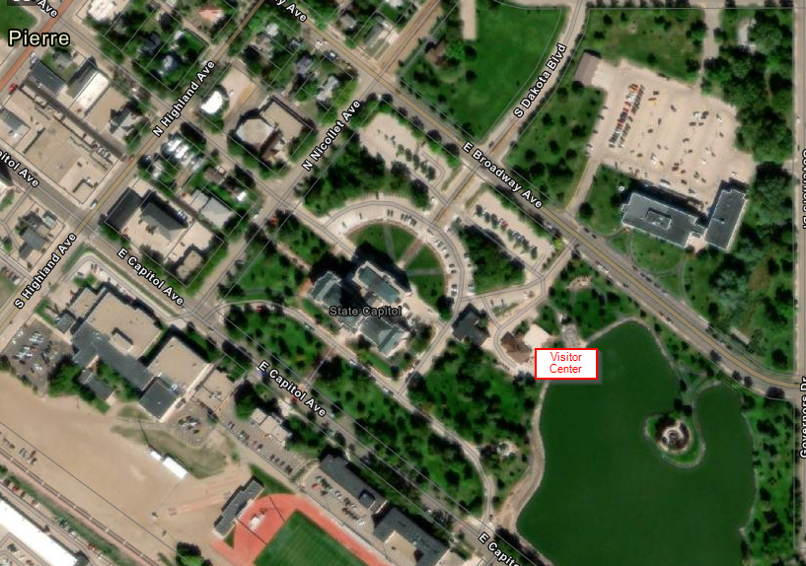

Class Schedule: Monday through Thursday
All classes will begin at 8:00 am and adjourn at 5:00 pm.
All classes will test on Friday morning starting at 8:00 AM.
Some courses may require some light homework.
There are breaks in the morning and afternoon where coffee and refreshments will be provided.

Meals
All school participants are responsible for their own meals.

School Rules
Attendance
Students are required to attend all sessions of the course they are taking. Roll will be taken in the classes and those students absent from any session will have points deducted from their test score. If the student has been absent from more than one session, credit for the school may be withheld and the student’s supervisor may be notified.

Cell Phones
Please observe these common cell phone courtesies:
- Have the phone turned off or to silent in the classroom.
- If you must take or place a call, do not do so in the classroom or in the hallway directly outside of the classrooms
- Calculators on phones are not allowed during tests

Required Texts and Class Materials
All course material will be provided unless otherwise noted. Students are responsible for bringing the “required texts” listed for their respective course. If you need assistance in acquiring a text, contact the Department of Revenue.

In addition to the required texts, students should bring
- a calculator the student is familiar with
  - cell phone calculators are not allowed during tests
- pencils, note pad, and other items normally used in class

Course Tests
No early tests will be allowed. Make up tests will be allowed only in accordance with the test policies laid out in administrative rule. Consult ARSD 64:02:03:19 for complete explanation of rules on testing and re-testing courses at the annual schools.

Course 1 – Basics (Fundamentals of Appraising/Assessing)
This course is for all beginning directors or staff that have not attended a previous school or for uncertified personnel enrolled in the certification program. This course will give a beginner’s look at the laws and procedures for appraising property for taxation in South Dakota. It also covers the three approaches to value; cost, market, and income. It is recommended that this course be taken before the CAA exam is attempted.

Instructor: Todd Bailey, CAA
Prerequisite: none
Required Texts: IAAO Property Assessment Valuation (2nd or 3rd edition)
Cost: $350

2023 Annual Assessor School

Make all checks payable to SDAAO

Tuition is $350 for Basics Course.

COUNTY _______________________

Contact email

_________________________________
Mail registration and payment to:
SDAAO
C/O Rhea Crane
1300 Sherman St, Ste 222
Sturgis, SD 57785

 | STUDENT NAME (print or type) | Course | Amount  submitting
1.
2.
3.
4.
5.
6.
7.
8.
 |  | TOTAL AMOUNT DUE: | $

