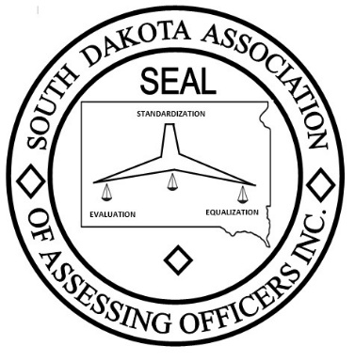
South Dakota Association of Assessing Officers
77th Annual Conference June 10 – 13 2025
Highland Conference Center
2000 Highland Way Mitchell, SD 57301
(605) 990-1575

Registration Due May 20th, 2025
Registration Fee: $250 Extra Banquet Tickets: $40
Name County & Title Extra Tickets Total Fee

__________________________ __________________________ ____________ ______________
Tuesday June 10th 2025

make checks payable to
SDAAO Treasurer
attn: Cori Kaufmann
200 E Center st
Madison, SD 57042
lakeequal4@lake.sd.gov

President’s Reception @ Village Bowl

Wednesday June 11th 2025
Keynote: Satoris Howes
“Leading with Compassion in Times of Uncertainty”
Round Tables

Thursday June 12th 2025
Call to Freedom: “The Intersection of Human Trafficking & Housing”
Variety of 1-hour sessions
Banquet with entertainment from Dueling Duos

